**FORECASTING**

**Business Problem** = ﻿ ﻿Forecast the Airlines Passengers data set.

* **Name of the File: -** Airlines Data.xlsx
* **Size of the File: -** 12 KB
* **Necessary Data : -** 96 Observations, 2 Features.

**Exploratory data Analysis** =

* **Dummy Variable: -** Creating 12 Dummy Variables for 12 Months.
* **Missing Value: -** Data don’t have Missing Values
* **Output:** - Forecasted Value.

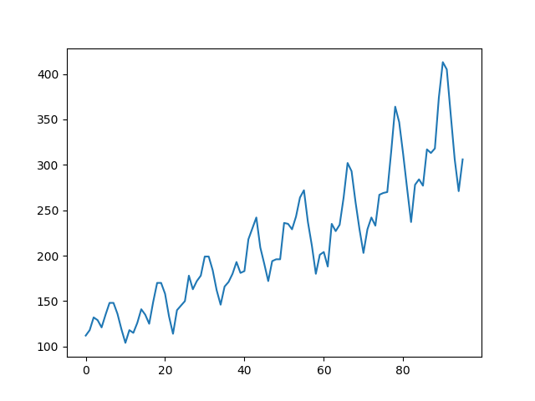

**﻿Time Series Plot =**

* **﻿Trend :-** Upward Trend
* **﻿Seasonality :-** Multiplicative Seasonality

**Models Building =** Building Various Regression model and selecting optimized model with low RMSE for the future predication.

|  |  |
| --- | --- |
| **Type of Model** | **RMSE** |
| Linear Model | ﻿53.2 |
| Exponential Model | 46.05 |
| Quadratic Model | 48.05 |
| ﻿Additive seasonality Model | ﻿132.81 |
| Additive seasonality Quadratic Trend Model | 26.36 |
| Multiplicative Seasonality Model | ﻿140.06 |
| Multiplicative Additive Seasonality Model | 10.51 |

After building various models as shown in the above table with respective RMSE values, the Multiplicative additive Seasonality model has the least RMSE value due to which we use it for Future Predication.

**Python code file**: - [Airline Forecasting.py](https://github.com/nilaydeshmukh0/Forecasting/blob/master/Airline%20Forecasting/Airline%20Forecasting.py)